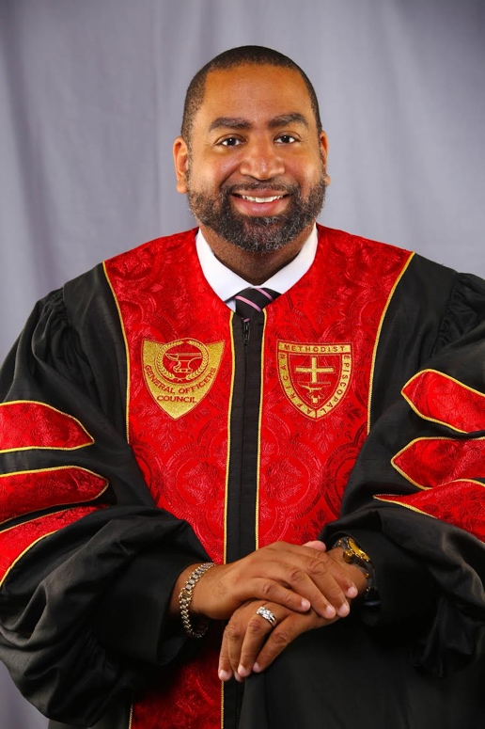
REV. DR. MARCELLUS. A. NORRIS
Rev. Dr. Marcellus Alexander Norris was born in Newark, NJ to Bishop Richard F. and Mrs. Mary Ann Norris. Rev. Norris is married to Mrs. Anethia Theress Norris and have two sons, London Nicholas and Marcellus Alexander II.
Dr. Norris accepted the call to preach on August 6, 1995 at St. Matthew A.M.E. Church, Philadelphia, PA, where then Rev. Richard F. Norris was the pastor. He preached his trial sermon on September 24, 1995 and received the license to preach on September 25, 1995. A third generation A.M.E. preacher, Marcellus graduated in May 2007, from Lutheran Seminary at Gettysburg with a Master’s of Divinity Degree. On May 14, 2021, Dr. Norris earned his Doctor of Ministry degree from Payne Theological Seminary, Wilberforce, OH.

Pastor Norris has pastored the following churches: Bethel A.M.E. Church, McConnellsburg, PA, St. Peters A.M.E. Church, Shippensburg, PA, Bethel A.M.E. Church, West Chester, PA, Bethel A.M.E. Church, Bryn Mawr, Pa, Bethel A.M.E. Church, Norwalk, CT, & St. Paul A.M.E. Church, Cambridge, MA.

On January 22, 2012, Pastor Norris was assigned to St. Luke A.M.E. Church, New York, NY. Rev. Norris came in and hit the ground running with a Vision and a Ministry of Excellence for St. Luke. Pastor Norris introduced to St. Luke, the “E” Factor, which constitutes the Principles of Excellence. Under his leadership, he was able to stabilize the finances of the church by paying off one loan in two years. Since St. Luke loves to travel the world to worship and evangelize, Rev. Norris and St. Luke purchased a 25 passenger minibus. Under Rev. Norris’ leadership, St. Luke started an after school program in 2013 which serves over 60 children. This program expanded in 2014 by teaching the Hispanic community English as a second language.
Rev. Norris has liquidated $1,000,000 in nine years as a testament of financial stewardship. The mortgage was burned on November 7, 2021. The administrative building has been updated with high tech security cameras and the phone system has been upgraded. Pastor Norris took St. Luke through a critical period when the roof of the church was in dire need of repair. The hairline fractures in the roof trusses made the church inhabitable. Pastor Norris led the church in a fight with the insurance company that lasted for over 2 years. Rev. Norris led the church into a season of prayer and St. Luke was awarded $638,000 for the repairs. The roof was repaired and the church marched back into the sanctuary on November 7, 2021.
In November 2012, Rev. Norris was appointed by Bishop Ingram as the First Episcopal District Chairman of Christian Education, a position he still holds today. Pastor Norris is currently the President of the New York Police Department 30th Precinct Clergy Council.
Pastor Norris is a member of Alpha Phi Alpha Fraternity, Incorporated. Pastor Norris is a Master Mason and member of Xenia Lodge #50.
On July 11, 2021, in Orlando, FL, at the 51st Session of the General Conference of the AME Church, Rev. Marcellus A. Norris was elected the Executive Director of Church Growth and Development of the AME Church.

